Novel Process for Bio-jetfuel Production Through the Furan Pathway. Techno-Economic, Environmental and Safety Assessment
Melissa Pamela Hinojosa-Esquivelª, Cesar Ramirez-Marquez^{b}, Julio Cesar Velazquez-Altamiranoª, Juan José Quiroz-Ramirez ^{c}, Juan Gabriel Segovia-Hernandez^{d}, Gabriel Contreras-Zarazua^{c,d}
ªEscuela Superior de Ingeniería Química e Industrias Extractivas Instituto Politécnico Nacional s/n Edificio 7, de, Av Instituto Politécnico Nacional, Lindavista, Ciudad de México, CDMX, 07738, México.
^{b}Departamento de Ingeniería Química, Universidad Michoacana de San Nicol ́as de Hidalgo, Morelia, Mich 58060, Mexico.
^{c}CONACYT-CIATEC, A.C. Centro de Innovación Aplicada en Tecnologías Competitivas. Omega 201, Industrial Delta, 37454 León, GTO, México.
^{d}Departamento de Ingeniería Química, Universidad de Guanajuato, Noria Alta s/n, Guanajuato, Gto., 36050, México.
g.contreras@ugto.mx
Abstract
This study proposes a new biofuel production process using furans derived from lignocellulosic residues to convert them into gasoline, bio-jet fuel, or diesel. The process consists of three fundamental stages: aldol condensation, hydrodeoxygenation (HDO), and separation. Different catalysts and technologies were evaluated using as metrics the total annual cost (TAC), the eco-indicator 99 (EI99), and the individual risk (IR) to determine the economic, environmental and safety aspects of the process, respectively. This metrics were chosen in order to evaluate the sustainability of each technology. The results indicate that a process using DBU as a catalyst is the option with the best trade-off between environmental impacts, costs, and safety. This process shows costs and environmental impact reductions of up to 75% compared to other typical processes such as ATJ.
Keywords: Furans to fuels, Furans to jet, FTJ, Biofuels
  - Introduction
Currently, there is a clear need to replace fossil fuel energy sources with renewable energy sources to address climate change accelerated by the accumulation of greenhouse gases and the increasing costs of oil extraction. Data from the Energy Information Administration (IAE) indicate that the transportation sector is highly dependent on fossil fuels, which accounted for 96.8% of all the energy required by this sector in 2018 (EIA, 2022). In the United States alone, the transportation sector annually consumes the equivalent of 37% of the generated energy, representing the emission around 2000 million tons of carbon dioxide, surpassing emissions from other sectors such as industrial or residential (EIA, 2022). To reduce the transportation sector's dependence on fossil fuels and decrease its greenhouse gas emissions, a process of electrifying the transportation sector has been initiated, where the automotive sector is the main driving force. However, electrification presents some disadvantages that have made its implementation impossible in some sectors of transportation, such as aviation. Some of these limitations are the power-to-weight ratio, the capacity for storage, and the power generated by batteries, as well as the lack of infrastructure for a fast implementation of electrification. Therefore, the use of alternative energy sources, such as biofuels, emerges as a viable alternative to achieve a carbon-neutral or negative transportation sector (IRENA, 2021).
Despite the environmental and economic benefits of biofuels, their production remains expensive compared to fossil fuels. Although many studies have been conducted to improve biofuel production processes, most research efforts have focused on reducing production costs and finding new raw materials, rather than exploring new production routes (Ko et al., 2020). An alternative that has not been explored is the production of biofuels through the furan route, known as FTF (Furans to Fuels). The production of furans like furfural or HMF from lignocellulosic waste is widely known, and these bioproducts are already produced on an industrial scale, making them ideal raw materials for biofuel production. In addition, this route is thermochemical, which means that biochemical routes are not required, thereby reducing in this way resident time and increasing the yields to fuels. Despite the benefits of this route, up to now, there has been not reported a process for producing biofuels, such as bio-jetfuel, using this route. Based on aforementioned, in this work is proposed the synthesis, design, and simulation of a novel biofuel production process from these furans. This process consists of three stages: aldol condensation, hydrodeoxygenation (HDO), and hydrocarbon separation. In each stage, different catalysts and technologies are analyzed. The total annual cost, Eco-Indicator 99, and individual risk were considered as metrics to evaluate the economic, environmental, and safety aspects of the different process options. These indicators were selected according to the 12 principles of sustainability proposed by Jimenez Gonzalez and Constable (2011).
  - Methodology
In this study, furfural was considered as the main furan produced from lignocellulosic residues: therefore, it was used as the main raw material for this novel process. It is important to note that this work does not consider the production of furfural from biomass, since this production has been extensively explored in previous studies. The process for producing biofuels from furfural consists of three stages: aldol condensation, hydrodeoxygenation (HDO), and a separation stage. This process was designed and simulated using the Aspen Plus software. The design was performed in order to minimize the energy requirement, which is directly related to lower operating costs. Due to the difference temperature and pressure conditions of each stage, as well as the compounds involved, the Carlson's algorithm was used to determine the most suitable thermodynamic model for each stage (Carlson, 1996).
During the aldol condensation stage, furfural and a ketone compound (commonly acetone) react in the presence of basic catalysts and solvents, generating higher molecular weight oxygenated compounds called adducts. These reactions can be carried out at conditions of 1 atm and temperatures between 25 °C and 58 °C to guarantee that the ketone remains in the liquid phase. In this stage three different catalyst were studied: dolomite, sodium hydroxide solutions, and 1,8-Diazabicyclo[5.4.0]undec-7-ene (DBU). A CSTR reactor was considered to carry out the reactions in this stage. The kinetic model for all the catalysts fits to the Arrhenius equation behavior and were taken from O’Neill et al., 2014 and Jiang et al., 2018. After producing the adducts, it's necessary to eliminate the oxygen in these compounds. Additionally, the double bonds must be removed to generate saturated compounds. This is essential to achieve the specific physicochemical properties needed for certain biofuels, like biojet -fuel, to meet ASTM standards. This oxygen and double bond removal is performed by means of the hydrodeoxygenation stage, where hydrogen is added. The oxygen reacts with the hydrogen to form water. This reactive stage can be performed in a fixed bed reactor over a Nickel- Platinum supported on alumina catalyst, at conditions of 10 to 50 atm and 200 to 400 °C. The kinetic parameters used to design and simulate this equipment were taken from Faba et al, (2016) whereas the missing kinetic parameters were estimated using the methodology proposed by Sánchez-Ramírez et al., (2022). Owing to the high pressures and temperatures required in this stage, the thermodynamic model used to simulate it was the Soave-Redlich-Kwong model.
During the HDO stage, water, unreacted hydrogen, and hydrocarbons(mainly octanes and tridecanes) are produced. The unreacted hydrogen is separated from the mixture using flash distillation. On the other hand, the water can be separated from the organic mixture using an azeotropic distillation column, due to the presence of azeotropes and two liquid phases. The azeotropic distillation process was proposed and designed according to the previous work reported by Contreras-Zarazua et al. (2018) in order to obtain anhydrous hydrocarbons. Once the water is removed, the hydrocarbons can be separated into different cuts using conventional distillation columns. The azeotropic distillation system was simulated using the NRTL-RK thermodynamic model due to the presence of organic compounds and water. On the other hand, the flash tank and the conventional distillation sequence were simulated using the Peng-Robinson method. Both thermodynamic models were chosen according to Carlson’s algorithm. Figure 1 shows a flowsheet of the novel proposed process.

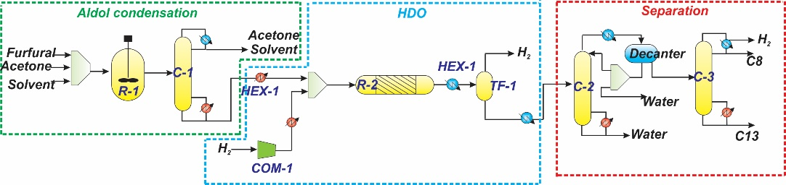
Figure 1. Process flowsheet for producing biofuels from furfural

As aforementioned, the Total Annual Cost (TAC), Eco-Indicator 99, and Individual Risks were the metrics selected to evaluate the economic, environmental, and safety aspects of the different process options. The Total Annual Cost is as shown below:

(1)
The TAC was calculated using Guthrie's method, considering a payback period of 10 years. Stainless steel was considered as the construction material. The costs were upgraded to the year 2023 using the chemical engineering plant cost index (CEPCI) of 816. The base costs corresponds to the year 2003 (CEPCI= 382). The necessary equations for estimating costs were taken from Turton et al., (2018). The operating costs were calculated considering 8500 hours of plant operation per year. Additionally, the following costs for services were considered: Cooling water ($0.355/USD/GJ), electricity ($16.8 USD/kWh), and Fired heat ($20.92 USD/GJ) Turton et al., (2018).

The Eco-Indicator 99 was the metric used to assess environmental impact, which is a life cycle methodology. The calculation for the eco-indicator was carried out according to what was reported by Contreras-Zarazua et al. (2020) The mathematical formula used to calculate the Eco-Indicator 99 is as follows:
(2)
Where, β_{b} represents the total amount of chemical b released per unit of reference flow due to direct emissions, α_{b,k} is the damage caused in category k per unit of chemical b released into the environment, ω_{d} is the weighting factor for damage in category d, and δ_{d} is the normalization factor for damage in category d, respectively. The values of the weights and each impact category were taken from Contreras-Zarazúa et al., (2020)

Finally, the Individual Risk Index (IR) was used to quantify the safety of the process. This index is calculated through a quantitative risk analysis methodology and aims to measure the probability of harm caused to a person located at a certain distance from the epicenter of the accident. To identify potential accidents that could occur in the process, the HAZOP method was used, and seven possible accidents were found, which were classified into two categories: instantaneous accidents (BLEVE, UVCE, flash fire, and toxic release) and continuous release accidents (fire dart, flash fire, and toxic release). The complete set of equations for each incident and for the calculation of the IR was presented by Medina-Herrera et al. in 2014. The mathematical expression that describes the individual risk is expressed as follows:

(3)
Where fi is the frequency with which incident i occurs, while P_{x,y} is the probability of injury or death caused by incident i.
  - Results
In this section, the results obtained during the sensitivity analysis for the different processes are shown. The results obtained with the sensitivity analysis are presented in
Table 1. Design specification for different the processes.
Design specifications | NaOH | Dolomite | DBU
Reactor volume R-1 (m³) | 20 | 10 | 1
Temperature reactor R-1 (°C) | 40 | 40 | 55
Pressure reactor R-1 (atm) | 1 | 1 | 1
Feed mass flowrate acetone (kg/h) | 600 | 500 | 3600
Solvent used | Methanol-Water (40-60%wt) | ------- | ------
Feed mass flowrate Solvent (kg/h) | 9000 | 0 | 0
Number of Stages Column C-1 | 13 | 14 | 60
Reactor volume R-2 (m³) | 11.7 | 26.9 | 19.79
Temperature reactor R-1 (°C) | 273 | 359 | 192
Pressure reactor R-2 (atm) | 45 | 25 | 45
Energy COM-1 (kW) | 22529 | 16600 | 13081
Number of Stages Column s C-2 | 50 | 40 | 50
Number of Stages Column C-3 | 50 | 50 | 5
Mass flow C8 (kg/h) | 2.46 | 411.33 | 10.3
Mass flow C13 (kg/h) | 851.39 | 585.49 | 912.2
Total energy of the process (kW) | 26231 | 10769 | 7012
Additionally, the results, such as cost, environmental impact, safety, as well as the sensitivity analysis for Reactor 1 of the NaOH process, which was selected as a representative case, are shown in Figure 2.

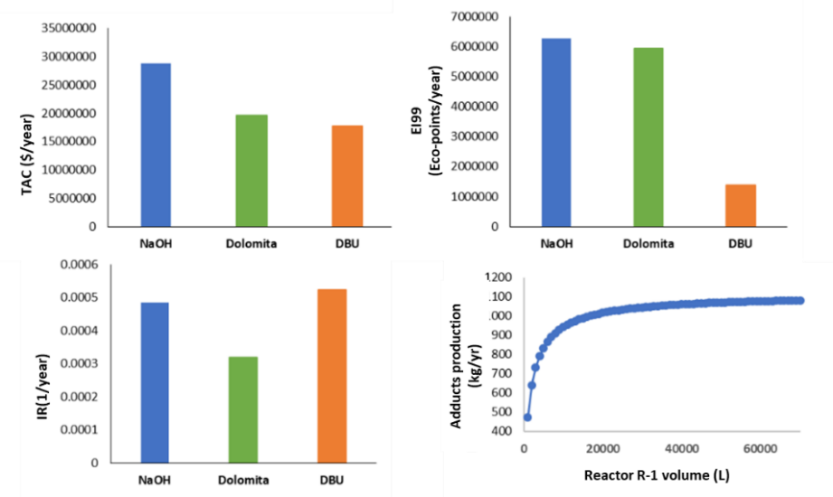
Figure 2. Results for TAC, EI99 for the process and sensitivity study for reactor R-1

As can be seen, of the three options, the process catalyzed with sodium hydroxide turned out to be the most expensive and with the highest environmental impact. This is mainly due to the fact that this process requires the use of a large amount of solvent (9000 kg/hr), which is composed of water and methanol. This causes not only an increase in cost and environmental impact due to the heating of a larger amount of solvent, but also an increase in the cost of water separation in the separation zone. Therefore, it is not surprising that this process is the one that requires the most energy, as can be seen in Table 1. It is important to note that this process is also very poorly selective to gasoline, with its main product being bio-jet fuel. Note also that this process is one of the worst in terms of safety, due to the need for higher pressure and temperature conditions to carry out the HDO reactions, this due to the dilution of the products with water.
In contrast, the process involving dolomite showed a lower total cost compared to the NaOH process. This is largely due to two important factors. Firstly, this process does not require the use of water, which significantly reduces the costs associated with heating and separating it. Secondly, this process is selective in the production of gasoline, as can be observed in Table 1. The hydrogenation of the gasolines is carried out under more moderate pressure and temperature conditions, which lowers the costs and significantly improves the safety of the process. It should be noted that, in this case, the reduction in costs does not correlate proportionally with the decrease in environmental impact. This is mainly because a greater amount of medium and low-pressure steam is required compared to the other processes, resulting in a lower environmental impact in economic terms, but not necessarily in environmental terms.
Finally, the DBU process proved to be the best in terms of cost and environmental impact. It should be noted that this process, like the hydroxide process, is not selective to gasoline. This is mainly because the process does not use solvents for the aldol condensation; instead, it increases the amount of acetone. This results in significant cost reductions in heating during the HDO stage and reduced operational costs in separation. This can be clearly seen in Table 1, where this process consumes 30% less energy than the dolomite process and about 75% less than the NaOH process. This cost and environmental impact reduction is contrasted with safety, which has drastically worsened. This is because a larger amount of acetone and higher temperatures are required to carry it out, in contrast to the other processes. In addition, it is important to note that acetone volatilizes easily, which has severe safety consequences. It is for this reason that the DBU presents greater risks. However, despite this, it is important to note that the difference in risks between the three processes is not much, so DBU is chosen as the best process for producing biofuels via the furan route.
  - Conclusions
It was determined that in terms of costs, the DBU process proved to be the most efficient, consuming 30% less energy than the dolomite process and about 75% less than the NaOH process. Regarding environmental impact, the dolomite-involved process showed a lower total cost compared to the NaOH process, as it does not require the use of water and is selective in gasoline production, but it requires a greater amount of medium and low-pressure steam. In terms of safety, the sodium hydroxide-involved process presented the highest risks due to the higher pressure and temperature conditions required. Although the DBU process presents higher risks, the difference in risks among the three processes is not significant. Overall, the results indicate that the DBU process is the most suitable for producing biofuels via the furan route, due to its cost efficiency and environmental impact. However, it is important to take appropriate measures to ensure safety in its application. To validate the feasibility of this process and to compare its costs with those of conventional fossil fuels, a supply chain study is suggested for future research."
References
Contreras-Zarazúa, G., Sánchez-Ramírez, E., Vazquez-Castillo, J. A., Ponce-Ortega, J. M., Errico, M., Kiss, A. A., & Segovia-Hernández, J. G. (2018). Inherently safer design and optimization of intensified separation processes for furfural production. Industrial & Engineering Chemistry Research, 58(15), 6105-6120.
E. Sánchez-Ramírez, B. Huerta-Rosas, J.J. Quiroz-Ramírez, V.A. Suárez-Toriello, G. Contreras-Zarazua, J.G. Segovia-Hernández, Optimization-based framework for modeling and kinetic parameter estimation, Chem. Eng. Res. Des. 186 (2022)
Faba, L., Díaz, E., Vega, A., & Ordónez, S. (2016). Hydrodeoxygenation of furfural-acetone condensation adducts to tridecane over platinum catalysts. Catalysis Today, 269, 132-139.
Jiménez-González, C., & Constable, D. J. (2011). Green chemistry and engineering: a practical design approach. John Wiley & Sons.
Ko, J. K., Lee, J. H., Jung, J. H., & Lee, S. M. (2020). Recent advances and future directions in plant and yeast engineering to improve lignocellulosic biofuel production. Renewable and Sustainable Energy Reviews, 134, 110390.
O’Neill, R. E., Vanoye, L., De Bellefon, C., & Aiouache, F. (2014). Aldol-condensation of furfural by activated dolomite catalyst. Applied Catalysis B: Environmental, 144, 46-56.
Turton, R., Bailie, R. C., Whiting, W. B., & Shaeiwitz, J. A. (2008). Analysis, synthesis and design of chemical processes. Pearson Education
U.S. Energy Information Administration (EIA), U.S. energy facts explained, (2022). https://www.eia.gov/energyexplained/us-energy-facts/.
I.R.E.A. (IRENA), Reaching zero with renewables biojet fuels, 2021. https://www.
irena.org/-/media/Files/IRENA/Agency/Publication/2021/Jul/IRENA_Reachi
ng_Zero_Biojet_Fuels_2021.pdf.

